Magna Electronics

Newmarket Ontario, Canada

September 30, 2021

Technical Electrical - Internship

To whom it may concern,

I am extremely excited to learn of potential student employment opportunities available at Magna Electronics, and wish to apply to such positions. I believe that my background and experience, combined with my passion for physics and integrated systems makes me a well-suited candidate for such a role. My engineering studies and previous employment experiences have allowed me to develop many skills that would be valuable to Magna Electronics. I am currently studying Engineering Physics and Computing at Queen’s University with a GPA of 3.84.

As a Project Engineering Co-op in the New Technology and Innovation Labs at Magna Mechatronics, I am responsible for developing several technical systems using a combination of electrical, mechanical and software design. Through the utilization of applied mathematics, I was able to develop laser animations for a Quantum Dot taillight that I designed and created computer vision algorithms for collision detection. I also designed programs in Python and C++ for several embedded devices and robotic systems utilizing a variety of sensors including IR, Radar and Ultrasonic.

As a Mechanical Design Intern, I have used tools such as SolidWorks and CAD software to assist in product design and Magna Electronics for connected devices. Please find the solid models of many of my work on my [GrabCAD](https://grabcad.com/nathan.pacey-1) and in the following pages of this document.

I am competent in programming languages such as; Python, C, C++, MATLAB, Java, HTML5 and CSS and have been responsible for data collection and analysis related to new product testing, design, and development. I am incredibly interested in using programming to simulate and solve real world problems using optimization algorithms and simple machine learning as illustrated in my [GitHub](https://github.com/NathanPaceydev/).

I am familiar with all aspects of Microsoft Office and have experience developing customer-facing documents as well as front-end/customer-facing web sites. Furthermore, I am competent in computer-aided design, software development and mathematical problem solving with a proficiency in technically challenging problems.

Throughout my career, I have contributed to positive business results by being effectively organized, able to manage multiple priorities at once and ensuring that I follow through assigned tasks to their conclusion. While I am independently motivated, I am also a team player that appreciates collective efforts and collaborates productively within group settings.

Simply put, I would be highly motivated to advance my knowledge of software engineering and physics by working for an enterprise that is leading the charge to innovate automotive technologies.

Thank you for your kind consideration and would enjoy the opportunity to discuss my application with you in the near future.

Sincerely,

Nathan Pacey

226-988-3313

Npacey01@gmail.com

Grab CAD: https://grabcad.com/nathan.pacey-1

GitHub: https://github.com/NathanPaceydev/

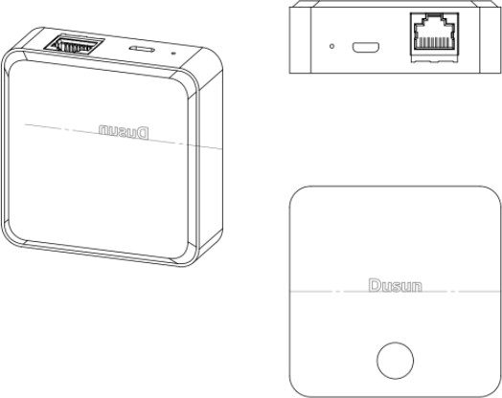

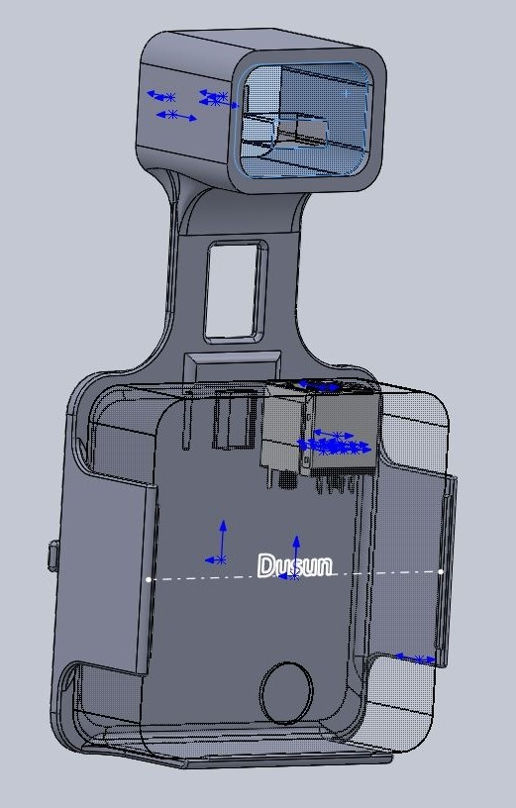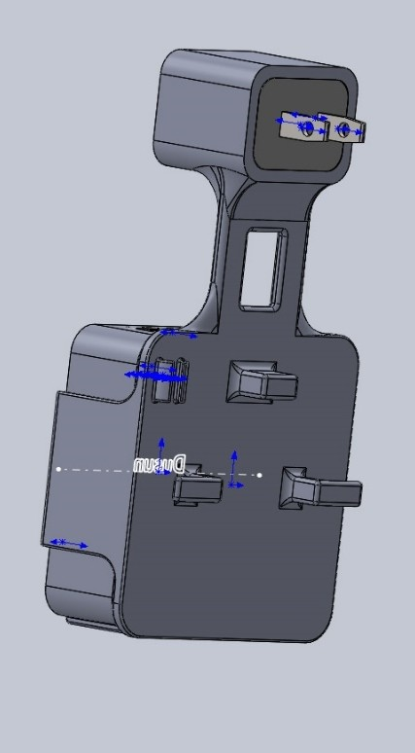*Figure 1: Heyyoka – Designed a mount and cable management bracket for a Smart Home Hub.*

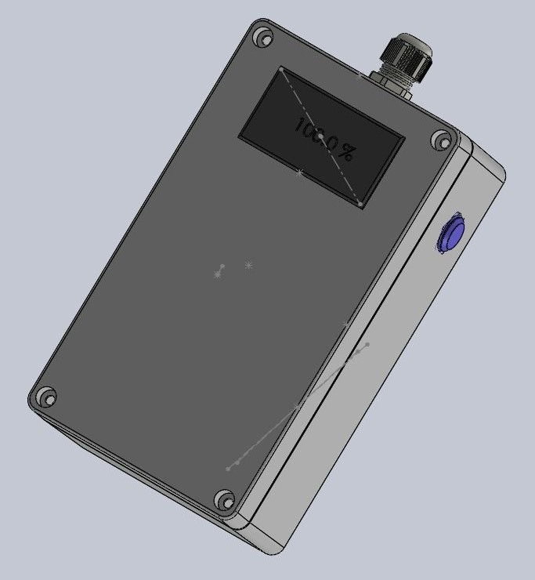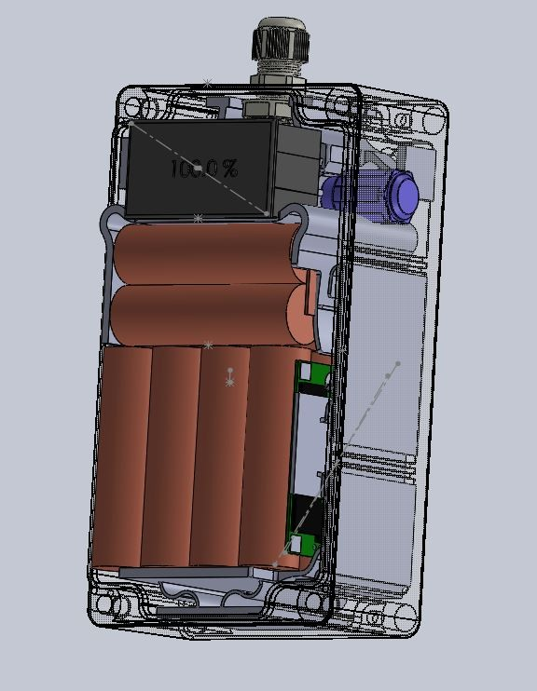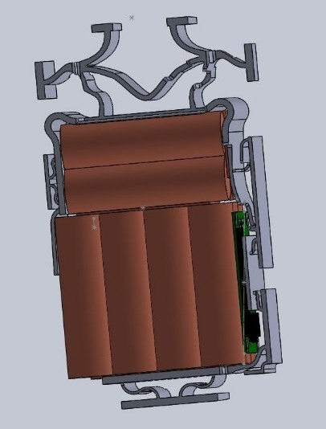

*Figure 2: Vision Spatial Technologies – Sourced and designed a battery system for SmartPatrol, a rugged environment intelligent alert system used at recreational resorts.*

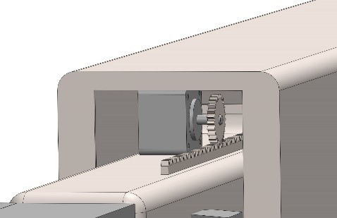

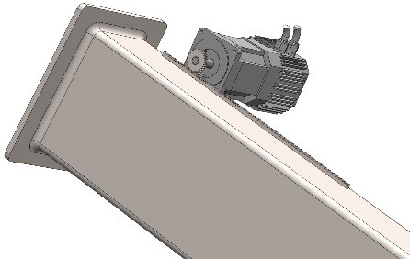*Figure 3: Queen's University and the Canadian Space Agency - Asteroid Sample Collection Device Concept for Osiris Rex.*

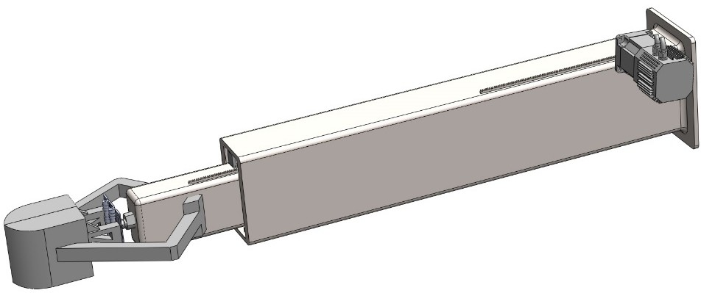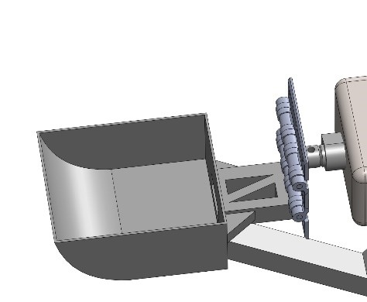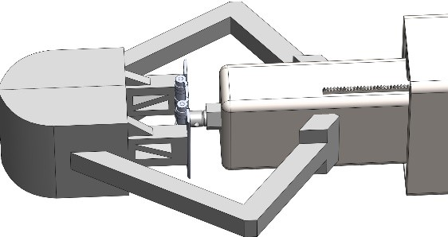

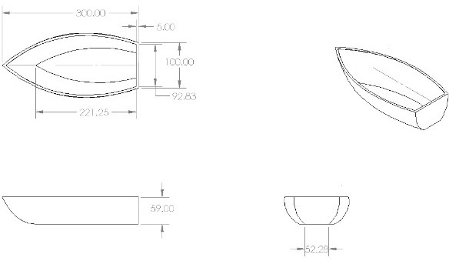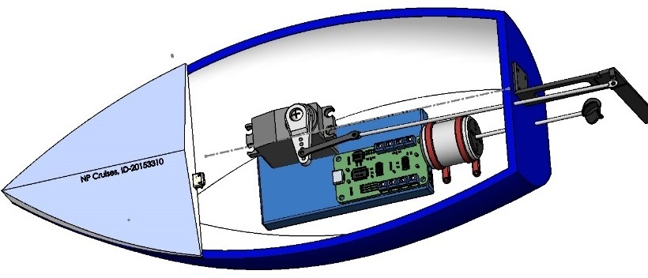

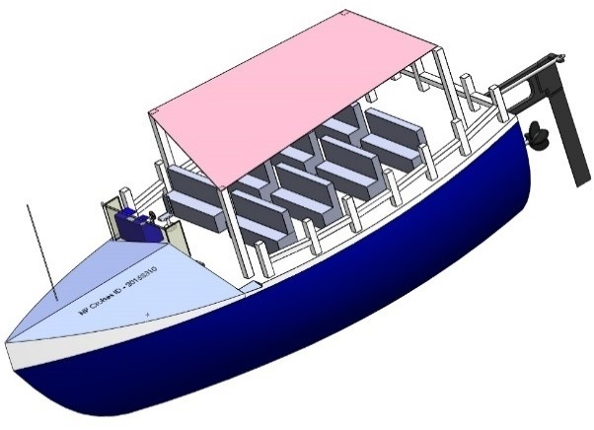

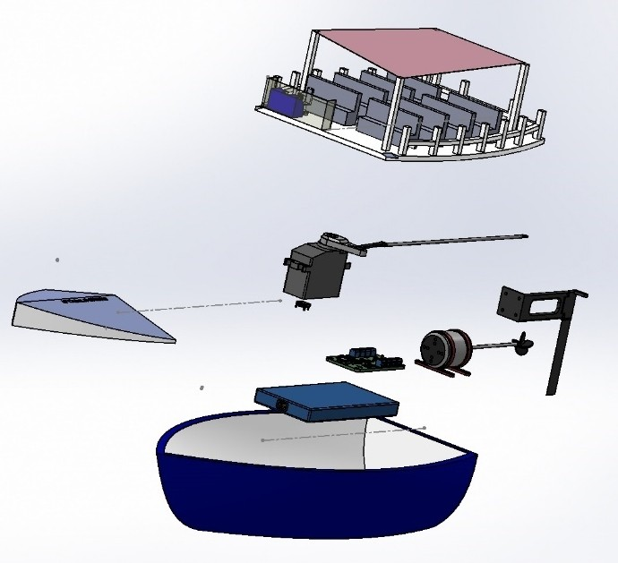*Figure 4: Queen's University - RC Boat Design.*